Project M: Markel First ProposalEngine
Business Requirements and Acceptance Criteria

1. Purpose

2. What we produce and when
 | Initial release | Subsequent release (backlog)
What we produce | EPICs: capability descriptions, interaction point, inputs/outputs, acceptance criteria, out of scope, open dependencies | User stories: finer-grained requirements by feature, with individual definitions of done and ready
Purpose | Protect scope. Give the client something to review and approve before build begins. | Drive the build. Give the engineering team implementation-ready requirements sprint by sprint.
Sign-off | Client reviews and approves EPICs before Phase 2 begins. Changes after sign-off follow the SOW change request process. | Client reviews and approves user stories on a rolling basis, ahead of build work. The goal is to define and approve all user stories as early as possible in Phase 2, not to tie sign-off to sprint boundaries.

3. EPIC set for the ProposalEngine
The EPIC’s to be completed and approved. The initial proposal engine will cover General Liability (GL) for the following set of class codes and industries:
Contractors

- 91582 - Contractors - subcontracted work - in connection with building construction, reconstruction, repair or erection - apartment or office buildings over four stories
- 91584 - Contractors - subcontracted work - in connection with construction, reconstruction, repair or erection of buildings - for industrial use
- 91585 - Contractors - subcontracted work - in connection with construction, reconstruction, repair or erection of buildings - Not Otherwise Classified
- 98678 - Roofing - residential - three stories and under
- 98677 - Roofing - commercial or residential over three stories
- 91342 - Carpentry - Not Otherwise Classified
- 91341 - Carpentry – interior
- 91560 - Concrete Construction
- 98449 - Plastering or Stucco Work
- 94381 - Fire Suppression Systems - installation, servicing or repair
- 92101 - Drilling - Not Otherwise Classified
- 91577 - Conduit Construction for Cables or Wires
- 99986 - Wrecking - buildings or structures - Not Otherwise Classified
- 97655 - Metal Erection - structural - Not Otherwise Classified
- 97653 - Metal Erection - nonstructural - Not Otherwise Classified
- 97222 - Machinery or Equipment - industrial - installation, servicing or repair
- 97223 - Machinery or Equipment - installation, servicing or repair - Not Otherwise Classified
- 95647 - Heating or Combined Heating and Air Conditioning Systems or Equipment - dealers or distributors and installation, servicing or repair - no liquefied petroleum gas (LPG) equipment sales or work
- 98483 - Plumbing - residential or domestic
- 98482 - Plumbing - commercial and industrial
- 97047 - Landscape Gardening
- 99507 - Swimming Pools - installation, servicing, or repair - below ground
- 98304 - Painting - exterior - buildings or structures - three stories or less in height - Not Otherwise Classified
- 98305 - Painting - interior buildings or structures
- 92478 - Electrical Work - within buildings
- 91746 - Door, Window or Assembled Millwork - installation metal
- 99969 - Welding or Cutting

OL&T

- 45190 - Hotels and Motels - with pools or beaches - less than four stories
- 45192 - Hotels and Motels - without pools or beaches - less than four stories
- 45191 - Hotels and Motels - with pools or beaches - four stories or more
- 45193 - Hotels and Motels - without pools or beaches - four stories or more
- 61212 - Buildings or Premises - bank or office - mercantile or manufacturing (Lessor's risk only)
- 48925 - Swimming Pools - Not Otherwise Classified
- 47051 - Real Estate Development Property
- 68706 - Warehouses - private (For-Profit)
- 68702 - Warehouses - occupied by multiple interests (lessor's risk only)
- 13673 - Grocery Stores (excluding Supermarkets with receipts in excess of $500,000 and area in excess of 3,000 sq. feet)
- 18501 - Supermarkets - with receipts in excess of $500,000 and area in excess of 3,000 square feet
- 44315 - Health or Exercise Facilities - commercially operated
- 12374 - Drugstores - no table or counter service for beverage or food
- 67635 - Shopping Centers - excluding indoor malls - buildings or premises not occupied by the insured (lessor's risk only)
- 46603 - Parking - public - not open air
- 46604 - Parking - public - open air
- 46606 - Parking - public - shopping centers - maintained by lessee - (lessor's risk only)
- 46607 - Parking - public - shopping centers - maintained by the insured - (lessor's risk only)
- 41677 - Consultants - Not Otherwise Classified
- 68606 - Vacant Buildings - not factories (For-Profit)
- 68607 - Vacant Buildings - not factories (Not-For-Profit)
- 68604 - Vacant Buildings – factories
- 49451 - Vacant Land - Other than Not-For-Profit
- 49452 - Vacant Land - Not-For-Profit onl

Habitational
- 60010 - Apartment Buildings
- 62003 - Condominiums - residential - (association risk only)
- 63011 - Dwellings - two-family (LRO only)
- 63012 - Dwellings - three-family (LRO only)
- 63013 - Dwellings - four-family (LRO only)
- 68500 - Townhouse Associations (association risk only)
- 46202 - Mobile Home Parks or Courts
- 10331 - Campgrounds (For-Profit)
- 61000 - Boarding or Rooming Houses
- 63010 - Dwellings - one-family (lessor's risk only
- 48924 – Swimming Pools – Commercially Operated
- 48925 – Swimming Pools – Not Otherwise Classified
- 46671 – Parks and Playgrounds
- 46622 – Parking – Private
- 46603 – Parking – Public – note open air
- 46604 – Parking – Public – Open air
- 46606 – Parking – Public – Shopping centers – maintained by lessee – (LRO only)
- 46607 – parking – public – shopping centers – maintained by insured – LRO only
- 48727 – streets, roads, highways or bridges – existence and maintenance hazard only
- 41667 – clubs – civic, service or social – having buildings (for profit)
- 41668 – clubs - civic, service or social – having buildings (non-for-profit)
- 10105 – boat storage and moorage
- 14731 – laundries and dry cleaners – self service

List of Commercial Excess codes to be provided by project week 4 or 5 – From Will or Tony

The following non-GL add-ins will be applied:
- Inland Marine endorsement to the GL primary form
- Commercial Excess over the GL primary (follows form or may tighten terms with increased limits)

EPIC ID | Stages | Name | Description
EPIC-10 | PREPARE-TO-UW | Submission intakes prepare for analysis | Ingest unstructured submission (e.g., emails describing risk, ACORD forms, supplemental questionnaires, and loss runs) to confirm necessary data available to underwrite, rate, and construct and initial proposal. Process should block until complete and 10min SLA only starts when the complete set of data is available for processing.
EPIC-20 | PREPARE-TO-UW | Routing and human in the loop handling for submission intakes prepare for UW analysis and rating | Human in the loop corresponding with brokers to collect any missing submission information or react to clearance issues during the submission intake process (e.g., failed to pass OFAC check, broker of record issues, etc.)
EPIC-30 | PREPARE-TO-UW | Automatically collect 3rd party data necessary to underwrite and rate | Collect any 3rd party data related to the risk for underwriting and pricing purposes inclusive of crime score, D&B, OSHA/EPA/court data, credit report, and website scraping/analysis. Full list for general liability will be described.
Stage gate - before automated UW occurs
EPIC-40 | INITIAL-UNDERWRITE | Automatically prepare initial quotes | Prepare at least initial quotes based on submission data and 3rd party data collected. These may include:  Minimal coverage with maximum exclusions  Target premium optimized with exclusions, terms (e.g., limits, agg limits, sub limits, deductibles, etc.), and suggested coverages and exclusions forms.  Advised and balanced coverage price optimized for protecting insured balancing cost and coverage.  A la Carte pricing with additional policy features associated with price (e.g., simplified add’l insured, add pollution coverage cost).  Initial pricing, forms, and subjectivities will be on the generated proposals.
Stage gate – Post automated UW – Human in the loop
EPIC-50 | ROUTE-TO- UNDERWITER | Underwriter routing and interface to pull and finalize submission | When automated UW is complete a human need to start the review process and finalize sending out the submission.
EPIC-60 | HL-UNDERWRITE | Submission human in the loop review and modify user interface and data model | Provide user interface and data model to store to enable review and modification of the submissions and high-level control of proposal creation, copy, or identify differences between proposals
EPIC-61 | HL-UNDERWRITE | Proposal human in the loop review and modify user interface and data model | Provide user interface and data model to store to enable review and modification of the proposals.
EPIC-62 | HL-UNDERWRITE | Proposal comparison view | Describe the views and capabilities related to viewing two proposals and their differences
EPIC-70 | BIND-ISSUE | Bind and issue policy with E2 integration | Finalize collection of subjectivities and all steps necessary to bind and issue the policy. Send selected proposal to e2 to start bind and issue process.  (Target phase 1 if possible)
Application Support Services
EPIC-80 | UW-SUPPORT | Rating and pricing integration | Interface protocol and data exchange formats to call HX rating with modifiers to retrieve both technical rate and develop market pricing which will be provided by the HX engine.
EPIC-90 | UW-SUPPORT | Form document selection integration | Integrations with the FAST document management system to get the initial form list for a given code, the selection. Figure out where forms required fields to be filled in.
EPIC-100 | UW-SUPPORT | Quote packet generation | Provide the quote proposal and summary information sent to brokers and append form specimens.
EPIC-110 | ALL STAGES | Document storage integration with ImageRight and Cytora | Access and store documents via ImageRight. This inclusive of initial submission documents and persisting any proposal PDFs generated.
EPIC-120 | ALL STAGES | Document processing and intelligent extraction | Enable document extraction and vectorization for advanced AI based analytics of documents.
EPIC-130 | ALL STAGES | AI model rules and underwriting inference engine | This is the collective AI models and engines that will build out the forms and pricing based in UW inputs, 3rd party data and calls to the forms and rating/pricing integrations.
EPIC-140 | ALL STAGES | Rule viewer interface which may enable modification commonly changed parameters | Create UI Administration that drive syncing with administration information, view of rules where configurable, and light modification ability. (e.g., fees by state, authority level amounts, etc.)
EPIC-150 | ALL STAGES | User authentication, authorization, and authority limits | Users SSO and sign-on, group setting, authorization levels, and authority limits.
EPIC-160 | ALL STAGES | Audit, versioning + traceability | Log all submission inputs, scoring outputs, UW overrides, and model/prompt versions with full audit trail and quote versioning

4. EPIC Details

Submission intakes prepare for analysis (EPIC-10, PREPARE-TO-UW)

Description

Ingest unstructured submission (e.g., emails describing risk, ACORD forms, supplemental questionnaires, and loss runs) to confirm necessary data available to underwrite, rate, and construct an initial proposal. The process should block until complete, and the 10-minute SLA starts only when the complete set of data is available for processing.

CURRENTLY PLANNED TO BE COMPLETED BY CYTORA: Agreed to determine if this is in scope and needs to be documented and defined by 4/13/2026 (which is after 3 weeks of the project start).

Interaction points

TBD

Key inputs

TBD

Key outputs

TBD

Acceptance criteria

TBD

Out of scope

TBD

Routing and human in the loop handling for submission intakes, prepare for UW analysis and rating (EPIC-20, PREPARE-TO-UW)

Description

Human in the loop corresponding with brokers to collect any missing submission information or react to clearance issues during the submission intake process (e.g., failed to pass OFAC check, broker of record issues, etc.)

CURRENTLY PLANNED TO BE COMPLETED BY CYTORA: Agreed to determine if this is in scope and needs to be documented and defined by 4/13/2026 (which is after 3 weeks of the project start).

Interaction points

TBD

Key inputs

TBD

Key outputs

TBD

Acceptance criteria

TBD

Out of scope

TBD

Automatically collect 3rd party data necessary to underwrite and rate (EPIC-30, PREPARE-TO-UW)

Description

Collect any 3rd party data related to the risk for underwriting and pricing purposes, including crime score, D&B, OSHA/EPA/court data, credit report, and website scraping/analysis.

Through the initial submission, an automated call will be used to collect the following information for use by the UW:

Website scraping/analysis: Use off-the-shelf web scraping tools to crawl the website, identifying the business's activities and services, and potential underwriting risk indicators.

Cap Index: Pull crime score report used by UW to evaluate the risk

Company data owned by Markel: Leverages existing Markel sources of data for the entities:

Credit report from Expedia

OSHA/EPA/court data public record search

Dunn & Bradstreet company overview

Interaction points

This data will be pulled, associated with the submission record, and stored for future reference. For each integration, a blob will be retrieved and stored in the DB. A summery

Key inputs

TBD

Key outputs

TBD

Acceptance criteria

TBD

Out of scope

TBD

Automatically prepare initial quotes (EPIC-40, INITIAL-UNDERWRITE)

Description

Prepare at least initial quotes based on submission data and 3rd party data collected. These may include:

Minimal coverage with maximum exclusion: The “minimum to get on a job site.”

Target premium: Optimized with exclusions, terms (e.g., limits, agg limits, sub limits, deductibles, etc.), and suggested coverages and exclusions forms.

Advised and balanced coverage price: Optimized for protecting insured balancing cost and coverage.

A la Carte: pricing with additional policy features associated with price (e.g., simplified add’l insured, add pollution coverage cost)

Initial pricing, forms, and subjectivities will be on the generated proposals.

Interaction points

TBD

Key inputs

TBD

Key outputs

TBD

Acceptance criteria

TBD

Out of scope

TBD

Underwriter routing and interface to pull and finalize submission (EPIC-50,ROUTE-TO-UNDERWITER)

Description

The Submission & Proposal Routing Interface is a two-page workbench that lets underwriters triage incoming submissions, track them through an AI-assisted underwriting pipeline, and manage proposals from creation through binding. It is accessed via the left sidebar under Submissions & Proposals.

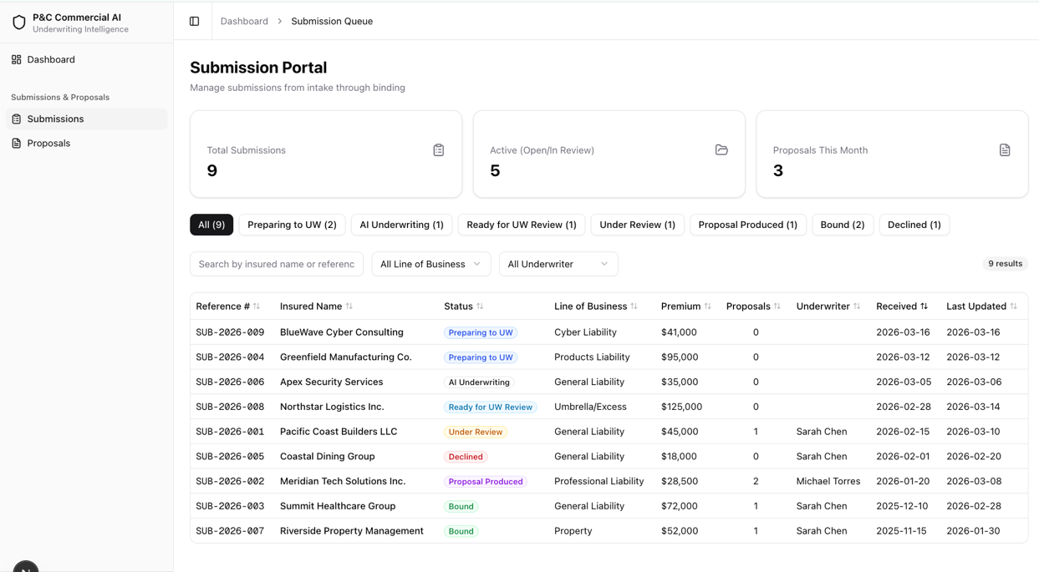

The interface models a seven-stage submission lifecycle that reflects an AI-first underwriting workflow:
Status | Label | Meaning
preparing_to_uw | Preparing to UW | Submission received; documents are being gathered and queued for AI processing. No underwriter is assigned yet.
ai_underwriting | AI Underwriting | The AI engine is actively analyzing documents, extracting structured data, running rating models, and flagging risk concerns. No underwriter is assigned yet.
ready_for_uw_review | Ready for UW Review | AI analysis is complete and the submission is queued for a human underwriter to pick up. No underwriter is assigned yet.
under_review | Under Review | An underwriter has claimed the submission and is actively reviewing AI outputs, loss runs, and supplemental information.
proposal_produced | Proposal Produced | One or more proposals (Good/Better/Best options) have been generated and are ready for broker presentation or internal approval.
bound | Bound | The broker has accepted a proposal and the policy has been bound. Terminal status.
declined | Declined | The submission was declined due to risk appetite, loss history, or other underwriting reasons. Terminal status.
Submissions in the first three statuses (Preparing to UW, AI Underwriting, Ready for UW Review) do not have an assigned underwriter. An underwriter is assigned when the submission transitions to Under Review.

Summary Stat Cards
Three KPI cards span the top of the page:
Card | Value
Total Submissions | Count of all submissions in the system
Active (Open / In Review) | Count of submissions in preparing_to_uw, ai_underwriting, ready_for_uw_review, or under_review
Proposals This Month | Count of proposals created in the current calendar month

Status Filter Tabs
A horizontal row of tabs appears below the stat cards. An All tab shows every submission; one tab per status shows only submissions matching that status. Each tab displays a count badge. Tabs are color-coded to match the status palette defined above.

Search and Filter Toolbar
Control | Behavior
Text search | Filters by insured name or reference number (case-insensitive substring match). Placeholder: “Search by insured name or reference…”
Line of Business dropdown | Filters by coverage line: General Liability, Professional Liability, Cyber Liability, Products Liability, Umbrella/Excess, Property
Underwriter dropdown | Filters by assigned underwriter name: Sarah Chen, Michael Torres
Clear Filters button | Resets all active filters, search text, and status tab to “All”
Result count | Displays “N results” reflecting the intersection of all active filters
All filters stack — selecting a status tab, typing a search term, and choosing a Line of Business dropdown value simultaneously narrows the result set to the intersection of all three criteria.

Submissions Table
Nine sortable columns:
Column | Data Field | Notes
Reference # | referenceNumber | Monospace font (e.g., SUB-2026-001)
Insured Name | insuredName | Primary identifier for the submission
Status | status | Color-coded badge using the status palette
Line of Business | lineOfBusiness | Coverage type (GL, PL, Cyber, etc.)
Premium | premiumIndication | Formatted as USD with no decimal places
Proposals | proposalCount | Integer count, centered
Underwriter | assignedUnderwriter | Blank for submissions in pre-review statuses
Received | receivedDate | YYYY-MM-DD format
Last Updated | lastUpdated | YYYY-MM-DD format
Sorting: Clicking any column header sorts ascending on that column; clicking the same header again toggles to descending. An arrow icon indicates the active sort column and direction. Default sort is Received date, newest first.
Row click: Clicking any row navigates to the submission detail page at /submissions/[id].
Empty state: When no submissions match the active filters, the table displays: “No submissions match the current filters.”

Interaction points
# | Interaction | Behavior
1 | Status tab click | Filters table to the selected status; clicking “All” removes the status filter
2 | Text search input | Live-filters table rows as the user types; matches against insured name and reference number
3 | Line of Business dropdown select | Filters table to submissions matching the selected coverage line
4 | Underwriter dropdown select | Filters table to submissions assigned to the selected underwriter
5 | Clear Filters click | Resets search text, dropdown selections, and status tab to “All”; table shows all submissions
6 | Column header click | Toggles sort direction (ascending/descending) on that column
7 | Table row click | Navigates to the submission detail page (/submissions/[id])

Key inputs

Input | Source | Description
Submission intake data | Broker / external system | Insured name, NAICS code, coverage line, effective/expiration dates, broker name, estimated premium. Populates the table row for each submission.
Status transitions | AI pipeline / underwriter | Automatic progression through AI stages (preparing_to_uw → ai_underwriting → ready_for_uw_review); manual transitions from under_review onward. Determines which status tab a submission appears under.
Underwriter assignment | System / manager | Assigned when a submission moves to under_review. Populates the Underwriter column and enables the Underwriter dropdown filter.
Proposal creation events | Underwriter (downstream) | Increments the Proposals column count and the Proposals This Month stat card.

Key outputs

Output | Consumer | Description
Filtered submission list | Underwriter | Prioritized, narrowed view of the submission pipeline based on status, coverage line, underwriter, and search terms
Summary statistics | Underwriter / management | At-a-glance KPIs: total volume, active count, and monthly proposal throughput
Status distribution | Underwriter | Per-status counts on the filter tabs reveal pipeline bottlenecks (e.g., many submissions stuck in Ready for UW Review)
Navigation to detail | Underwriter | Row click routes the user to the full submission workspace for in-depth review

Acceptance criteria

Status Lifecycle
- All seven statuses (preparing_to_uw through declined) render with correct labels, colors, and badge styling.
- Submissions in preparing_to_uw, ai_underwriting, and ready_for_uw_review display a blank Underwriter column.
- bound and declined are terminal statuses with no forward transitions.

Stat Cards
- Total Submissions displays the count of all submissions regardless of status.
- Active (Open / In Review) displays the count of submissions in preparing_to_uw, ai_underwriting, ready_for_uw_review, or under_review.
- Proposals This Month displays the count of proposals with a creation date in the current calendar month.
- All three counts update correctly when underlying data changes.

Status Filter Tabs
- The “All” tab is selected by default and shows every submission.
- Clicking an individual status tab filters the table to only submissions in that status.
- Each tab displays a count badge matching the number of submissions in that status.

Search and Filters
- Text search filters by insured name and reference number using case-insensitive substring matching.
- Line of Business dropdown filters the table to the selected coverage line.
- Underwriter dropdown filters the table to the selected underwriter.
- All filters (status tab, text search, Line of Business, Underwriter) stack — the result set is the intersection of all active criteria.
- Clear Filters resets search text, dropdown selections, and status tab to “All”.
- The result count label accurately reflects the number of visible rows.

Table
- All nine columns are present: Reference #, Insured Name, Status, Line of Business, Premium, Proposals, Underwriter, Received, Last Updated.
- All nine columns are sortable in both ascending and descending order.
- Default sort is Received date, descending (newest first).
- Premium values are formatted as USD with no decimal places.
- Clicking a row navigates to
- When no rows match the active filters, the empty state message “No submissions match the current filters.” is displayed.

Out of scope
- Role-based access control — All users see all submissions. Permission gating (e.g., restricting visibility by underwriter assignment) is deferred.
- Real-time updates / WebSocket push — Status changes and new submissions do not stream to other connected clients.
- Bulk actions — No multi-select or batch status transitions on the submissions list.
- Advanced search — No date-range filters, premium-range sliders, or saved/named filter presets.
- Submission creation — There is no “New Submission” intake form; submissions are assumed to arrive from an external broker portal or integration.
- Notifications and alerts — No email, Slack, or in-app notifications when a submission changes status.
- Export / print — No CSV export or print-optimized view of the submissions list.

Submission human in the loop review and modify user interface and data model (EPIC-60, HL-UNDERWRITE)

Description
Provide user interface and data model to store to enable review and modification of the submissions and policy proposal creation then send to a broker as a response. The Submission Detail page is the primary workspace for reviewing a single insurance submission. It is organized into four distinct sections: a Primary section that is always visible regardless of which tab is selected, and three tab panels — Overview, Loss Runs, and Structured Data — that the user switches between. Assume all fields are editable and come in via the document extraction step.
The page supports the full seven-status AI underwriting pipeline (preparing_to_uw through declined). Submissions in pre-review statuses display “Unassigned” for the underwriter.

Page Sections

Primary (Always Visible)
The Primary section remains on screen at all times, above the tab bar. It contains three sub-components stacked vertically.

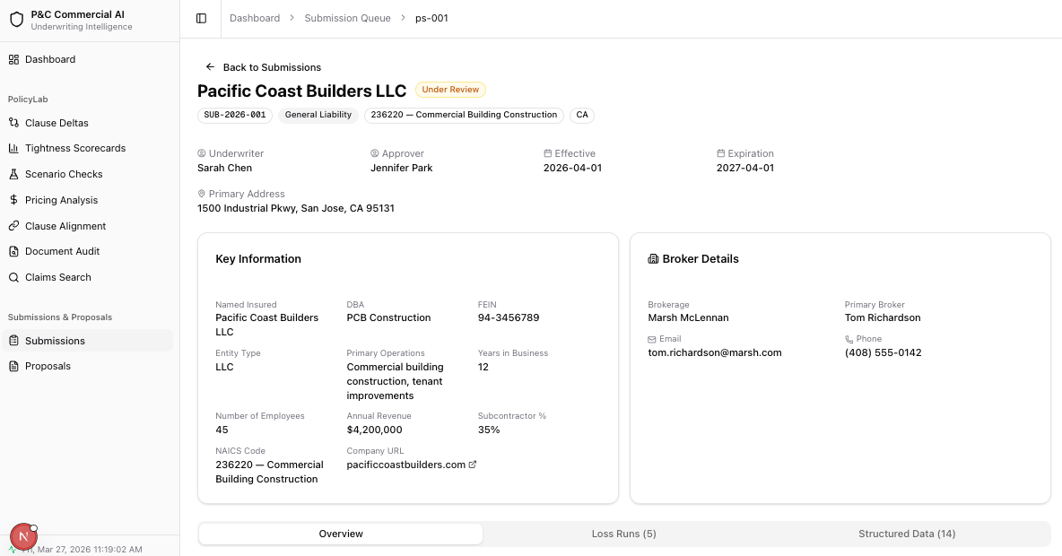

Displays the core identity and assignment information for the submission.
Element | Content
Back button | “Back to Submissions” — navigates to /submissions
Title | Insured name (e.g., “Pacific Coast Builders LLC”)
Status badge | Color-coded badge reflecting current submission status
Information badges | Reference number (monospace), Line of Business, NAICS code + description, State
Action buttons | “Change Status” (outline, conditional) and “Generate Proposal” (primary, conditional)

Assignment grid (up to 4 columns):
Field | Icon | Notes
Underwriter | UserCircle | Shows name or “Unassigned” for pre-review statuses
Approver | UserCircle | Only shown if an approver is assigned
Effective Date | Calendar | YYYY-MM-DD
Expiration Date | Calendar | YYYY-MM-DD
Primary Address (conditional): Shown below the grid with a MapPin icon if the submission has a primaryAddress value.

Key Information Card
A card displaying extracted structured fields from the Insured Information and Operations field groups, plus system-level fields.
Data | Source
Extracted fields | PortalStructuredField entries where fieldGroup is “Insured Information” or “Operations” (e.g., Named Insured, DBA, FEIN, Entity Type, Primary Operations, Years in Business, Number of Employees, Annual Revenue, Subcontractor %)
NAICS Code | submission.naicsCode — displayed as “code — description”
Company URL | submission.companyUrl — clickable external link opening in a new tab

Broker Details Card
A card displayed beside Key Information in a 2-column layout.
Field | Notes
Brokerage | Company name (e.g., “Marsh McLennan”)
Primary Broker | Contact person name
Email | Broker email address with Mail icon
Phone | Broker phone number with Phone icon

All broker fields except Brokerage are conditional — only displayed when present.

Overview Tab (Default)
A two-column layout (2/3 left, 1/3 right) containing the working content for the submission.

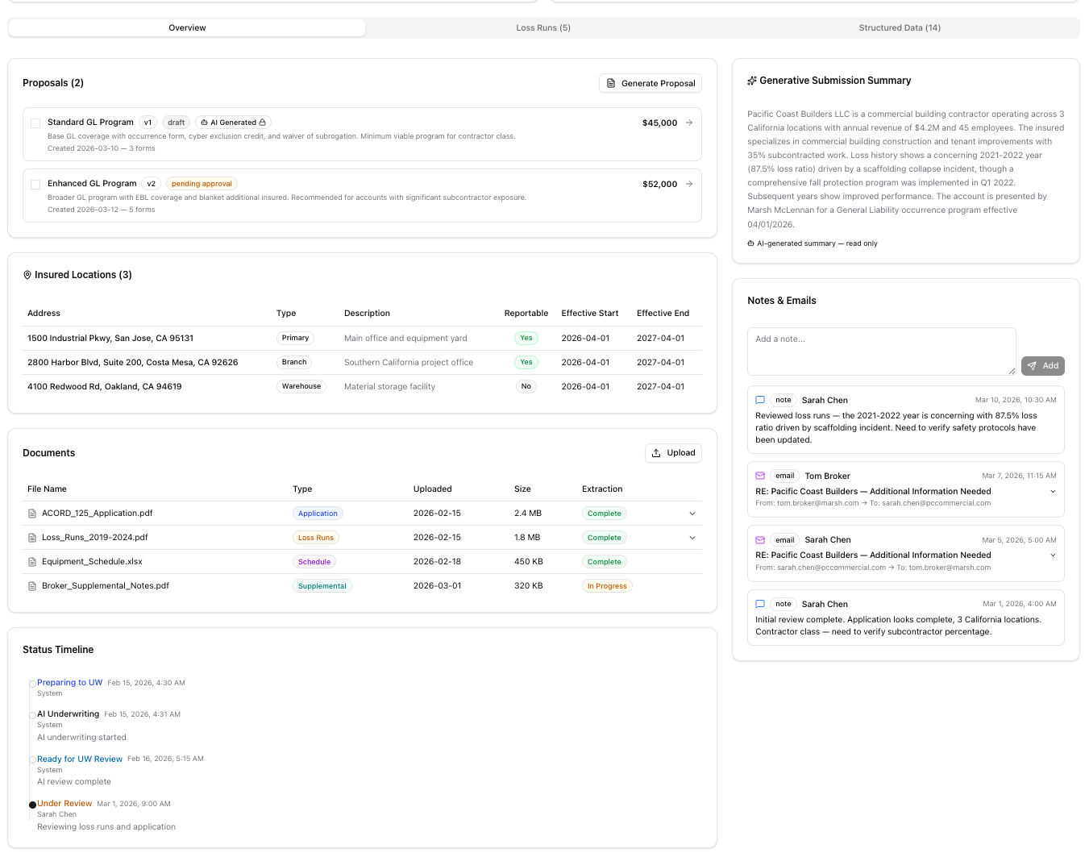

Left Column

Proposals Card
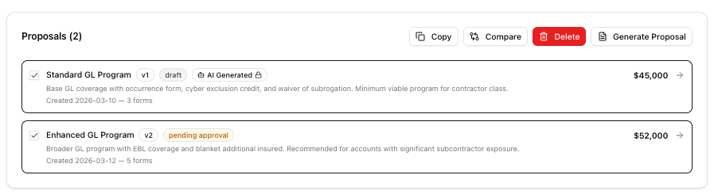
Displays all proposals linked to this submission with selection, action buttons, and navigation.
- Header: “Proposals (N)” with a “Generate Proposal” button.
- Checkboxes: Each proposal row has a checkbox on the left. Maximum of 2 can be selected at a time; additional checkboxes are disabled when 2 are checked.
- Action buttons (appear contextually when proposals are selected):
  - Copy — appears when 1+ selected; duplicates the selected proposal
  - Compare — appears when exactly 2 selected; opens a comparison view
  - Delete — appears when 1+ selected; hidden if all selected proposals are AI-generated (immutable)
- AI-generated badge: Proposals with aiGenerated: true display a violet “AI Generated” badge with Bot and Lock icons. These proposals cannot be deleted, only copied.
Each proposal row displays:
Element | Description
Checkbox | Selection control (max 2)
Label | Proposal name (e.g., “Standard GL Program”)
Version badge | “v1”, “v2”, etc.
Status badge | Color-coded: draft (zinc), pending_approval (amber), approved (green), declined (red)
AI badge | Violet badge with Bot + Lock icons (only for AI-generated proposals)
Description | 1–2 line description text (truncated with line-clamp)
Metadata line | “Created {date} — {N} forms”
Premium | Formatted as USD on the right side
Arrow | Navigation arrow; clicking the row navigates to proposal

Insured Locations Card
Shown when the submission has one or more insuredLocations. Displays a MapPin icon and count in the header. Each location is rendered as a bordered row with: - Address text - Type badge (e.g., “Primary”, “Branch”, “Warehouse”). Locations are displayed in a responsive 1–2 column grid.
This is the location schedule shared by all proposals and is the starting point for a schedule.

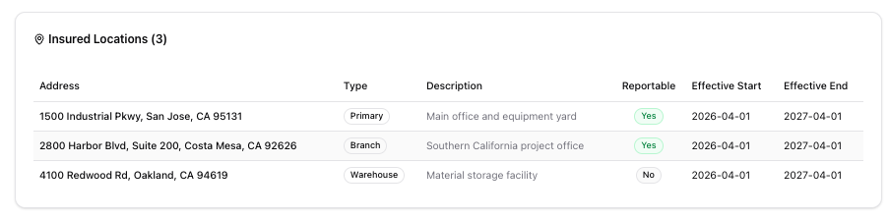

Documents Card
Manages uploaded documents with AI extraction status tracking. This reflects what is in the submission folders in ImageRight and any meta data related to the submission.
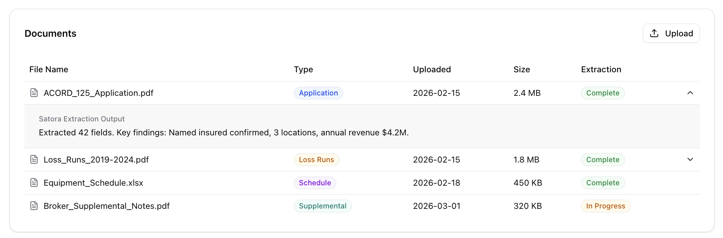
- Header: “Documents” title with an “Upload” button.
Documents table columns:
Column | Description
File Name | Document name with FileText icon
Type | Meta data from ImageRight — application, loss_runs, schedule, endorsement, supplemental, correspondence
Uploaded | Date in YYYY-MM-DD format
Size | File size (e.g., “2.4 MB”)
Extraction | Status badge — complete (green), in_progress (amber), failed (red), pending (zinc)
Expand | Chevron icon; only shown for documents with Satora extraction output
Expandable rows: Clicking a row with extraction output expands it to show the Satora extraction summary text (e.g., “Extracted 42 fields. Key findings: Named insured confirmed, 3 locations, annual revenue $4.2M.”).
Empty state: “No documents uploaded.”

Status Timeline Card
Vertical timeline showing chronological status progression.

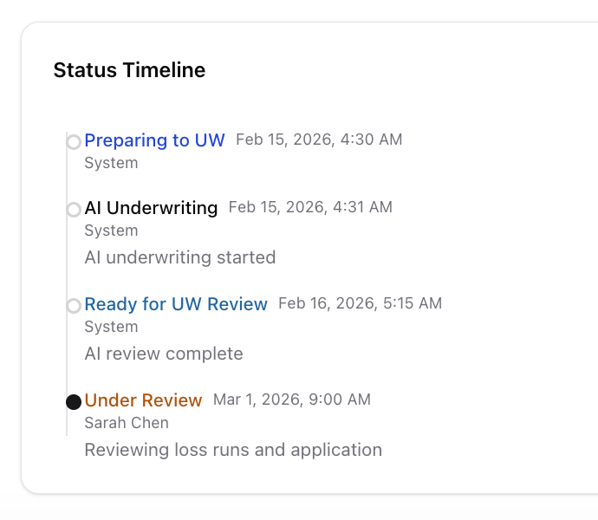
Each entry displays: - Dot: Filled circle for the latest entry, hollow circle for prior entries - Status label: Color-coded text matching the status palette - Timestamp: Formatted as “Mar 10, 2026, 2:30 PM” - User: Who made the status change (or “System” for automated transitions) - Note (optional): Additional context for the transition
The timeline reads top-to-bottom with the most recent entry showing a filled primary-colored dot and earlier entries showing hollow dots connected by a vertical line.

Right Column

Generative Submission Summary Card
Shown when the submission has an AI-generated submissionSummary. Read-only.

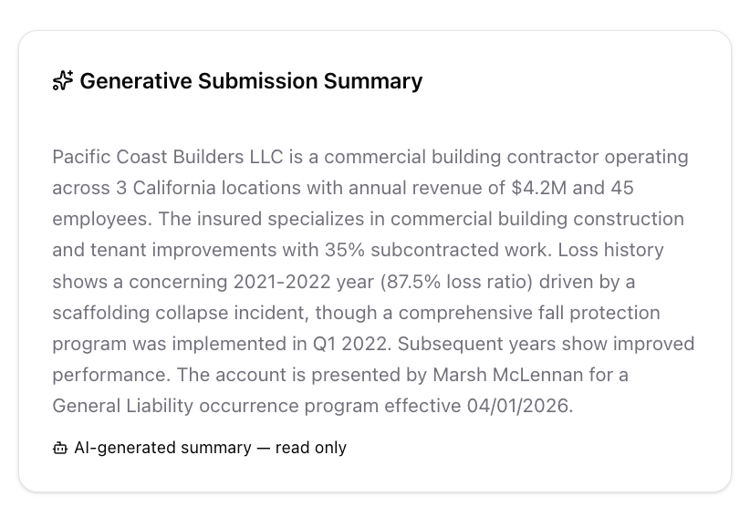
- Header: Sparkles icon with “Generative Submission Summary” title
- Body: Multi-sentence AI-generated narrative summarizing the submission (insured profile, loss history highlights, broker, coverage requested)
- Footer: Bot icon with “AI-generated summary — read only” in violet text

Notes & Emails Card
Chronological feed of internal notes and email correspondence. This is dependent on ImageRight to have the connections to emails that have been sent. Only Notes can be added. This will NOT send out emails.

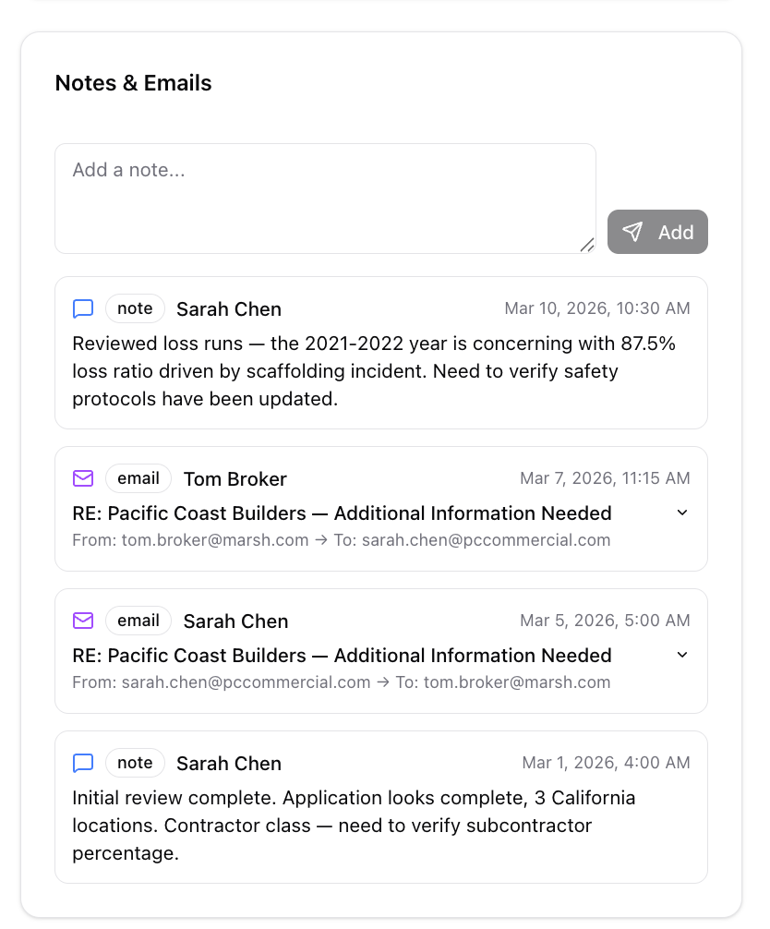
- Add Note section (top): Textarea (“Add a note…”) with Send button. Disabled when empty. Hidden when in readOnly mode.
- Feed: Sorted newest-first. Each entry shows:
  - Icon: Blue MessageSquare for notes, purple Mail for emails
  - Type badge: “note” or “email”
  - Author: Bold name
  - Timestamp: Right-aligned, formatted date/time
  - Content: For notes — plain text with whitespace preserved. For emails — collapsible section showing subject line, from/to addresses, and expandable body.
- Empty state: “No notes or emails yet.”

Loss Runs Tab
Displays historical loss data with summary calculations that are extracted and normalized by Cytora
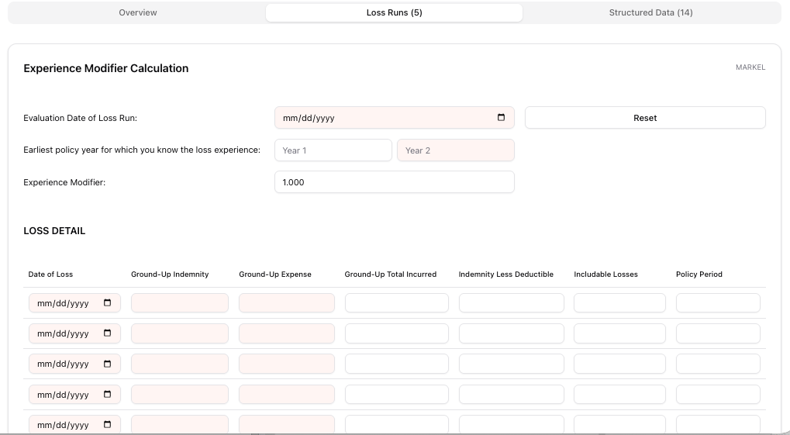

Card | Calculation
3-Year Weighted Avg Loss Ratio | totalIncurred / totalPremium for first 3 policy years
5-Year Weighted Avg Loss Ratio | totalIncurred / totalPremium for first 5 policy years
Loss History Table (8 columns):
Column | Format | Notes
Policy Year | Text | e.g., “2023-2024”
Carrier | Text | Insurance carrier name
Premium | USD | No decimal places
Claims | Integer | Claim count
Incurred | USD | Total incurred losses
Paid | USD | Paid amount
Reserves | USD | Outstanding reserves
Loss Ratio | Percentage | Color-coded: red (>60%), amber (>40%), green (<=40%)

Large Losses Section (conditional — only shown if large losses exist):
Column | Format
Policy Year | Text
Description | Loss description text
Amount | USD
Status | Badge — “open” (amber) or “closed” (zinc)
GL-specific variant: When the submission’s Line of Business is “General Liability”, the tab renders a specialized Experience Modifier component instead of the standard loss run table.
Empty state: “No loss run data available.”

Structured Data Tab
Displays AI-extracted fields organized by category with confidence scores and manual override capability. This will be finalized as the AI models and extraction are completed. This is purely for illustration.

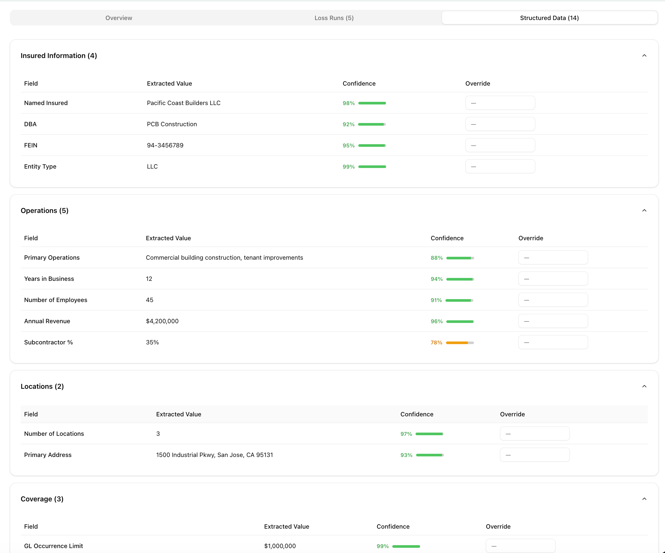

Field Groups (collapsible sections): - Groups are created dynamically from the fieldGroup property on each field - Default expanded groups: “Insured Information”, “Operations”, “Coverage”, “Locations” - Each group header shows: group name + field count (e.g., “Insured Information (5)”) - Clicking the header toggles expansion; ChevronDown icon rotates 180 degrees when open
Fields Table (within each group, 4 columns):
Column | Description
Field | Field name (e.g., “Named Insured”, “Annual Revenue”)
Extracted Value | Original AI-extracted value
Confidence | Visual confidence bar + percentage (e.g., 98%). Uses ConfidenceScore component
Override | Text input field for manual corrections. Shows amber Pencil icon when an override value exists. Placeholder: “—”
Override values are stored separately and do not replace the original extracted value — both are preserved.
Empty state: “No structured data available.”

Interaction points
# | Interaction | Section | Behavior
1 | Back button click | Primary — Header | Navigates to /submissions list page
2 | Change Status button | Primary — Header | Opens status transition dialog (conditional — only shown when handler provided)
3 | Generate Proposal button | Primary — Header / Overview — Proposals | Initiates AI or manual proposal creation workflow
4 | Company URL click | Primary — Key Information | Opens company website in a new browser tab
5 | Tab switch | Tab bar | Switches visible content between Overview, Loss Runs, and Structured Data
6 | Proposal checkbox toggle | Overview — Proposals | Selects/deselects a proposal (max 2); enables contextual action buttons
7 | Copy button | Overview — Proposals | Duplicates the selected proposal(s) as a new editable version
8 | Compare button | Overview — Proposals | Opens side-by-side comparison of 2 selected proposals
9 | Delete button | Overview — Proposals | Deletes selected proposals (hidden for AI-generated proposals)
10 | Proposal row click | Overview — Proposals | Navigates to proposal detail page at /submissions/[id]/proposals/[proposalId]
11 | Upload button | Overview — Documents | Creates a new pending document entry
12 | Document row expand | Overview — Documents | Expands to show Satora AI extraction output (only for documents with extraction results)
13 | Add Note submit | Overview — Notes & Emails | Appends a new internal note to the feed with current timestamp
14 | Email entry expand | Overview — Notes & Emails | Expands to reveal email subject, from/to addresses, and full body content
15 | Structured field override | Structured Data | Enters a manual correction value for an AI-extracted field
16 | Group expand/collapse | Structured Data | Toggles visibility of a field group’s contents

Key inputs
Input | Source | Description
Submission intake data | Broker / external system | Insured name, NAICS, coverage line, effective/expiration dates, broker details, primary address, company URL, insured locations
Uploaded documents | Broker / underwriter | PDFs (applications, loss runs, supplements) uploaded via the Documents card; trigger AI extraction pipeline
AI extraction outputs | Satora extraction engine | Structured fields with field group, field name, extracted value, and confidence score per document
AI submission summary | AI pipeline | Narrative summary generated from submission data and extracted fields; displayed read-only in the Generative Submission Summary card
AI-generated proposals | AI pipeline | Proposals with aiGenerated: true; immutable, can only be copied to create editable versions
Underwriter overrides | Human underwriter | Manual corrections to extracted structured fields via the Override column in the Structured Data tab
Internal notes | Underwriter | Free-text notes added via the Notes & Emails card
Email correspondence | Email integration | Inbound/outbound emails with subject, from/to, and body displayed in the Notes & Emails feed
Loss run data | Broker / carrier | Policy-year-level loss history including premium, claims, incurred, paid, reserves, and large losses
Status transitions | AI pipeline / underwriter | Automatic progression through AI stages; manual transitions from Under Review onward; recorded in Status Timeline

Key outputs

Output | Consumer | Description
Submission dossier | Underwriter | Complete view of the submission: insured profile, broker info, locations, documents, loss history, AI extractions, and status timeline — all accessible without leaving the page
Generative summary | Underwriter / management | AI-generated narrative summarizing the submission for quick triage and decision-making
Proposal list with selection | Underwriter | Actionable list of proposals with checkboxes enabling copy, compare (2 max), and delete operations
Structured data with overrides | Downstream systems / proposal generation | AI-extracted fields with human corrections; both original and override values preserved for audit
Loss ratio analysis | Underwriter | Weighted average loss ratios (3-year and 5-year) with color-coded thresholds for quick risk assessment
Status timeline | Audit trail | Chronological record of every status transition with actor, timestamp, and notes
Document extraction summaries | Underwriter | Satora AI extraction output providing at-a-glance summaries of document contents
Notes & email thread | Underwriter / broker | Complete correspondence and internal commentary history for the submission

Acceptance criteria

Primary Section (Always Visible)
- The header, Key Information card, and Broker Details card remain visible when switching between Overview, Loss Runs, and Structured Data tabs.
- Insured name and status badge display correctly; status badge uses the correct color from the seven-status palette.
- Reference number, Line of Business, NAICS code + description, and State appear as information badges below the title.
- Underwriter displays “Unassigned” for submissions in preparing_to_uw, ai_underwriting, or ready_for_uw_review.
- Approver field is only displayed when an approver is assigned.
- Primary Address displays with MapPin icon when present; hidden when absent.
- Key Information card shows all extracted fields from “Insured Information” and “Operations” groups, plus NAICS Code and Company URL.
- Company URL opens in a new tab when clicked.
- Override values in Key Information take precedence over extracted values.
- Broker Details card shows Brokerage, Primary Broker, Email, and Phone; optional fields are hidden when empty.

Overview Tab
- Proposals card displays correct count and lists all proposals for this submission.
- Each proposal row shows label, version, status badge, description, creation date, form count, and premium.
- AI-generated proposals display a violet “AI Generated” badge with Bot and Lock icons.
- Checkboxes allow selecting up to 2 proposals; checkboxes are disabled when 2 are already selected.
- Copy button appears when 1+ proposals are selected.
- Compare button appears only when exactly 2 proposals are selected.
- Delete button appears when 1+ non-AI proposals are selected; hidden if all selected proposals are AI-generated.
- Clicking a proposal row navigates to the proposal detail page.
- Insured Locations card displays all locations with address and type badge; hidden when no locations exist.
- Documents card lists all documents with file name, type badge, upload date, size, and extraction status badge.
- Upload button creates a new document entry with “pending” extraction status.
- Document rows with Cytora output expand to show extraction summary; rows without output have no expand control.
- Status Timeline displays all entries chronologically with correct status colors, timestamps, actors, and notes.
- Latest timeline entry has a filled dot; prior entries have hollow dots.
- Generative Submission Summary card displays the AI summary text when present; hidden when absent.
- Generative Summary is read-only with no edit controls.
- Notes & Emails card sorts entries newest-first.
- Adding a note via the textarea appends it to the feed with current timestamp and “Current User” author.
- Email entries are expandable to show subject, from/to, and full body.

Loss Runs Tab
- 3-Year and 5-Year weighted average loss ratio cards display correct calculated values.
- Loss History table displays all columns: Policy Year, Carrier, Premium, Claims, Incurred, Paid, Reserves, Loss Ratio.
- Loss Ratio values are color-coded: red (>60%), amber (>40%), green (<=40%).
- Large Losses section appears only when large losses exist for the submission.
- Large loss status badges use correct colors: “open” (amber), “closed” (zinc).
- GL submissions render the specialized Experience Modifier component instead of the standard loss run table.
- Empty state displays “No loss run data available.” when no loss runs exist.

Structured Data Tab
- Fields are grouped by fieldGroup and displayed in collapsible sections.
- Default expanded groups: “Insured Information”, “Operations”, “Coverage”, “Locations”.
- Each group header shows group name and field count; clicking toggles expansion.
- Confidence column displays a visual bar and percentage via the ConfidenceScore component.
- Override input accepts text input and shows an amber Pencil icon when a value is entered.
- Override values are stored separately and do not replace extracted values.
- Empty state displays “No structured data available.” when no fields exist.

Out of scope
- Document upload action: Creates a new document entry with type “supplemental” and extraction status “pending”. Plan for future phase
- Sending email via the notes section: Notes and email will only view emails not send emails. New emails will be discovered via ImageRight integration.
- Proposal detail page — The proposal detail view (/submissions/[id]/proposals/[proposalId]) with its Rates, Notes, and Forms tabs is covered by a separate epic.
- Proposal comparison view — The Compare button stubs navigation to a future comparison page; the comparison UI itself is not part of this epic.
- Role-based access control — All users can view and edit all submissions. Permission gating by role (underwriter, approver, admin) is deferred.
- Real-time collaboration — Multiple users editing the same submission concurrently (e.g., overrides, notes) is not supported.
- Notifications — No alerts when documents finish extraction, proposals are generated, or status changes occur.
- Print / export — No print-optimized view or PDF export of the submission detail page.

Proposal human in the loop review and modify user interface and data model (EPIC-61, HL-UNDERWRITE)

Description

Bind and issue policy with E2 integration (EPIC-70,BIND-ISSUE)

Description

The Proposal Detail page is the primary workspace for building, reviewing, and pricing a single insurance proposal within a submission. It provides a comprehensive pricing worksheet, forms management, and location scheduling interface.

The page operates in two distinct modes based on how the proposal was created:

Editable mode — The default for human-created proposals. All fields, limits, rates, forms, and locations can be modified. Search bars, add/remove buttons, and input fields are all visible and functional.

Read-only mode — Applied automatically to AI-generated proposals (aiGenerated: true). A violet banner with Bot and Lock icons indicates immutability. All input fields render as static text, all add/remove/edit controls are hidden, and all checkboxes are disabled. The user must copy the proposal to create an editable version.

Page Sections

Primary (Always Visible)
The Primary section remains on screen above the tab bar at all times. It contains navigation, an optional AI immutable banner, the proposal header, and a summary + notes area.
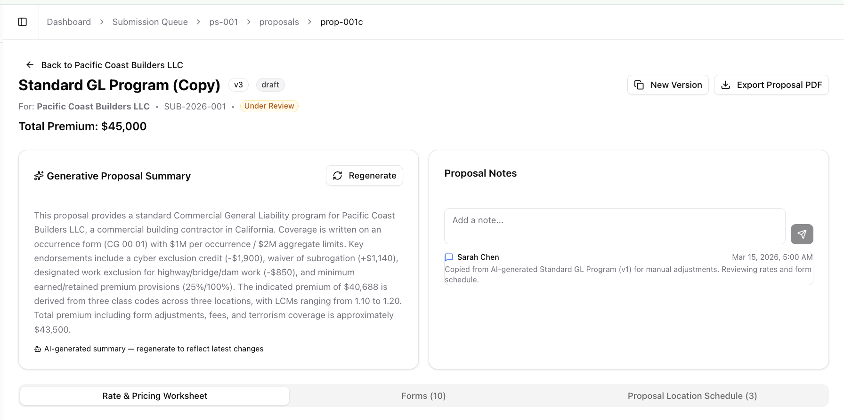

Back Link
A ghost button with ArrowLeft icon navigating back to the parent submission detail page (/submissions/[id]). Label reads "Back to {Insured Name}".

AI Immutable Banner (Read-Only Proposals Only)
Displayed only when the proposal has aiGenerated: true. A violet-bordered banner with Bot and Lock icons, title "AI-Generated Proposal — Read Only", and description: "This proposal was generated by AI and cannot be edited. Copy it to create an editable version."

Proposal Header
Displays the proposal label, version badge (v1, v2, etc.), status badge (draft/pending_approval/approved/declined with color coding), AI Generated badge (violet, for AI proposals only), context line showing insured name, reference number, and submission status badge, and total premium formatted as USD.
Action buttons (right-aligned):
Button | Condition | Behavior
Copy to Edit / New Version | Always shown. Label is "Copy to Edit" for AI proposals, "New Version" otherwise | Duplicates the proposal as a new editable version
Export Proposal PDF | Always shown | Generates and downloads a PDF export of the proposal
Send Proposal to Broker | Only shown when status === “approved” | Sends to document management system FAST/Ghostdraft to construct proposal document and append forms with species watermark. The system will send via email to the broker and persist the offer in ImageRight for future reference.
Approve | Only shown when !readOnly && status === "pending_approval" | Approves the proposal
Decline | Only shown when !readOnly && status === "pending_approval" | Declines the proposal

Generative Proposal Summary & Notes
A two-column layout (50/50 on large screens) displayed below the header and above the tab bar.
Generative Proposal Summary Card (left): Sparkles icon header with Regenerate button (RefreshCw icon). Displays a multi-sentence AI-generated narrative describing the proposal's coverage structure, key endorsements, pricing methodology, and total premium. Footer: Bot icon + "AI-generated summary — regenerate to reflect latest changes".

Proposal Notes Card (right): Textarea ("Add a note...") with Send button (disabled when empty). Scrollable feed (max 280px) sorted newest-first. Each entry shows MessageSquare icon for notes or Mail icon for emails, author name, timestamp, and content. Empty state: "No notes yet."

Tab Bar
Three tabs available: Rate & Pricing Worksheet (default, value: pricing), Forms (N) showing form count, Proposal Location Schedule (N) showing location count, and Subjectivities shared by the submission and all proposals in the submission.

Rate & Pricing Worksheet Tab
A two-column layout (2/3 left worksheets, 1/3 right sticky price summary). This is the core pricing workspace.

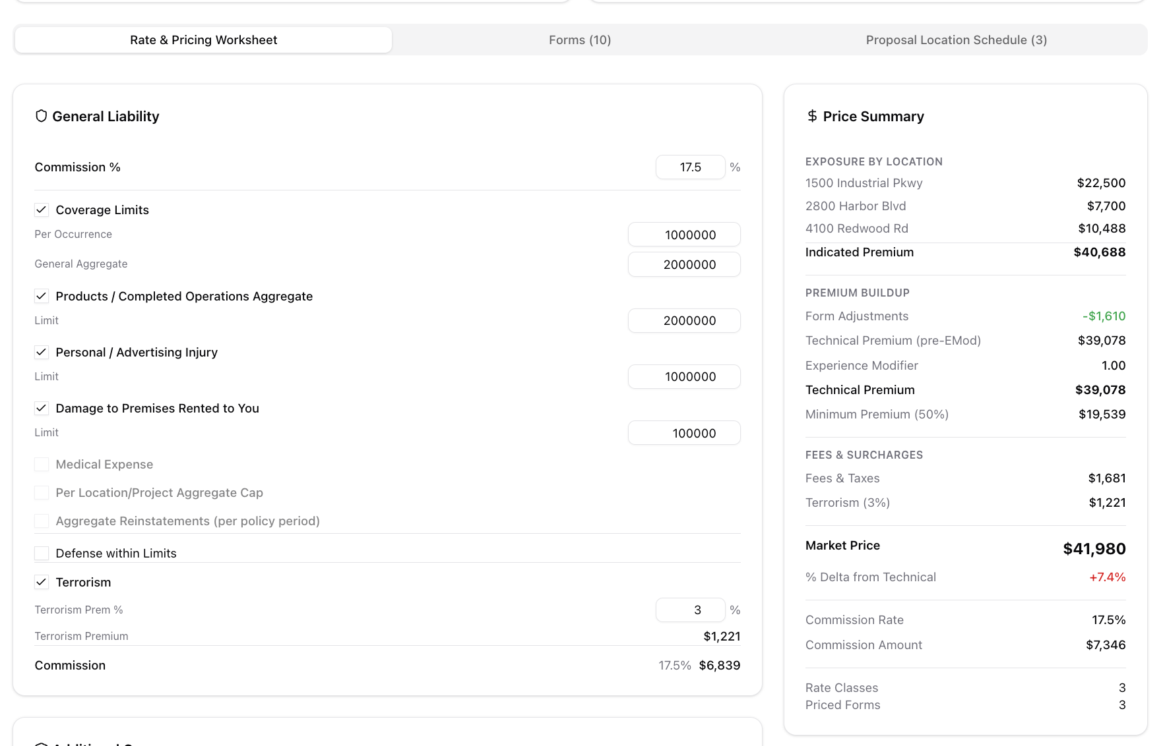

General Liability Card
Contains commission rate, coverage limits with enable/disable checkboxes, terrorism toggle, and defense within limits.

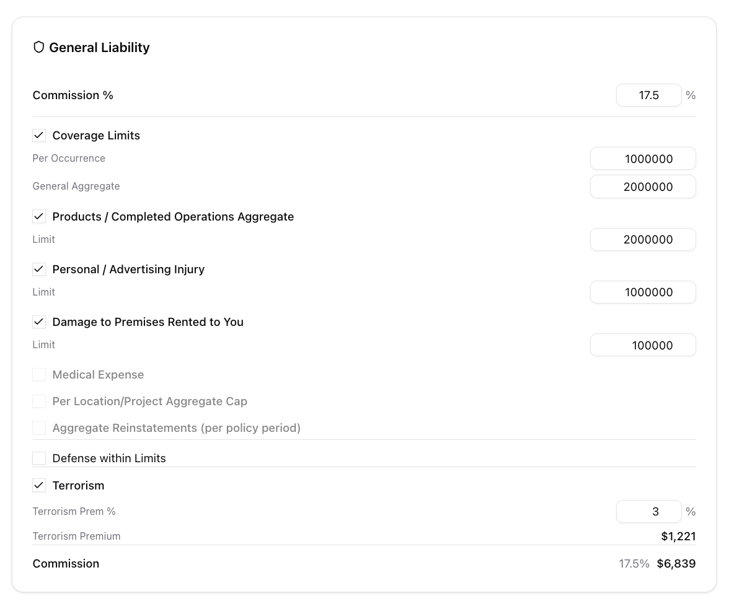

Commission Rate: In editable mode, a number input (0-100, step 0.5) with % suffix. In read-only mode, static percentage text. Other coverage list and defaults during analysis phase.
Editable mode: Checkboxes toggle coverage on/off. Limit amounts are editable number inputs. Disabled coverages are dimmed (opacity-50). Read-only mode: Checkboxes disabled, limits shown as static formatted currency.
Defense within Limits: Single checkbox, always unchecked by default. Terrorism: Checkbox toggles terrorism coverage. Rate % is editable (0-100, step 0.1). Terrorism Premium is calculated. Commission (bottom): Shows commission rate and calculated amount based on final premium.

Price Summary
This price summary is for the UW to review and understand what will be presented to the broker and how we came from technical rate to price.
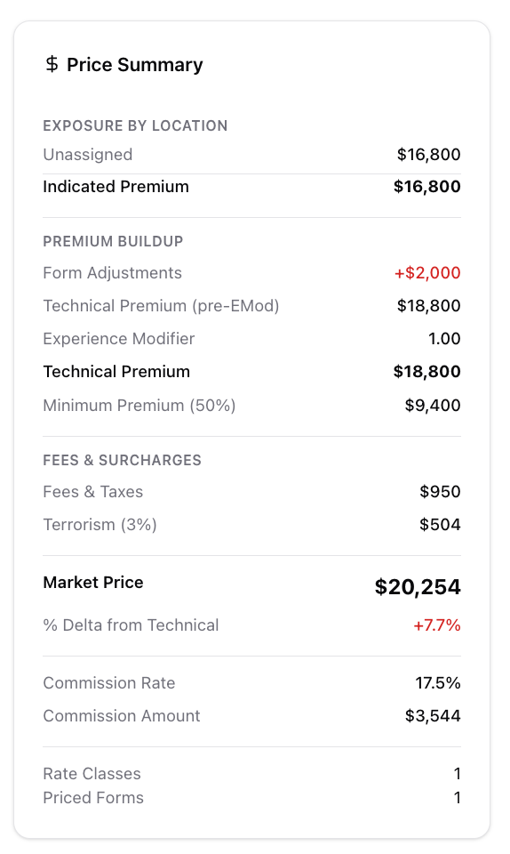

Additional Coverages

The UW or the AI model can offer additional coverages such as Inland Marine or Excess. The Amount will be displayed for the additional coverage per the rate basis selected.

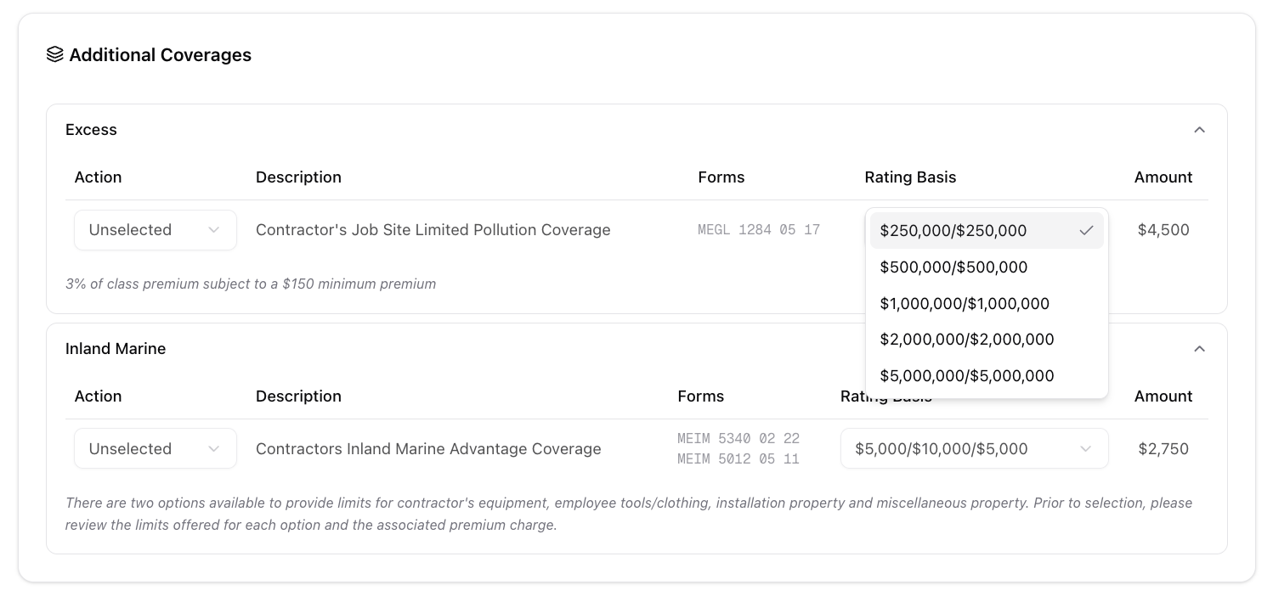
The user will have the ability to “Add” the additional coverage to the proposal or have it displayed as an “Offer Add-on” which displays to the broker what additional cost would be for the extra coverage.

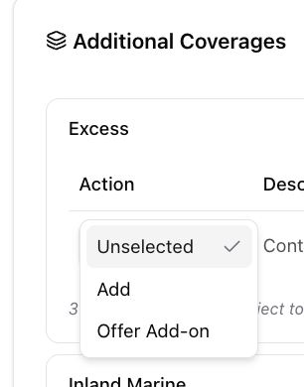

Deductibles

This is the deductible list shown to the UW and initially set by the AI model.

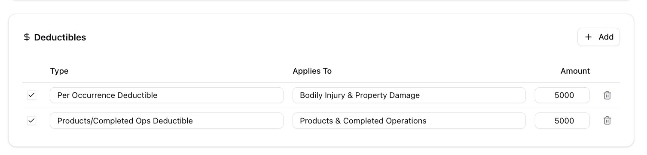

Fees

The UW or the AI model can offer additional coverages such as Inland Marine or Excess. The Amount will be displayed for the additional coverage per the rate basis selected.

Exposure Details

The UW or the AI model can offer additional coverages such as Inland Marine or Excess. The Amount will be displayed for the additional coverage per the rate basis selected.

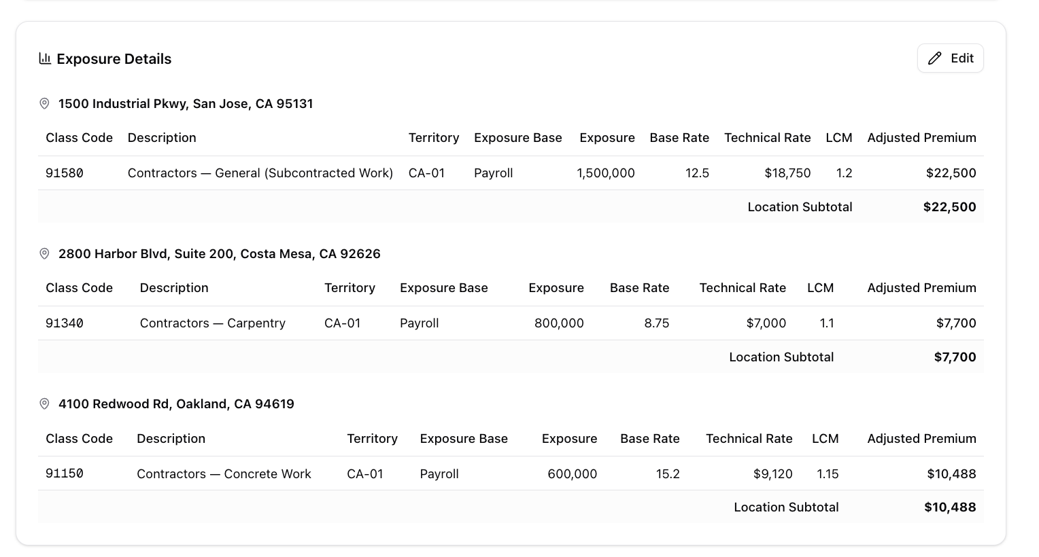

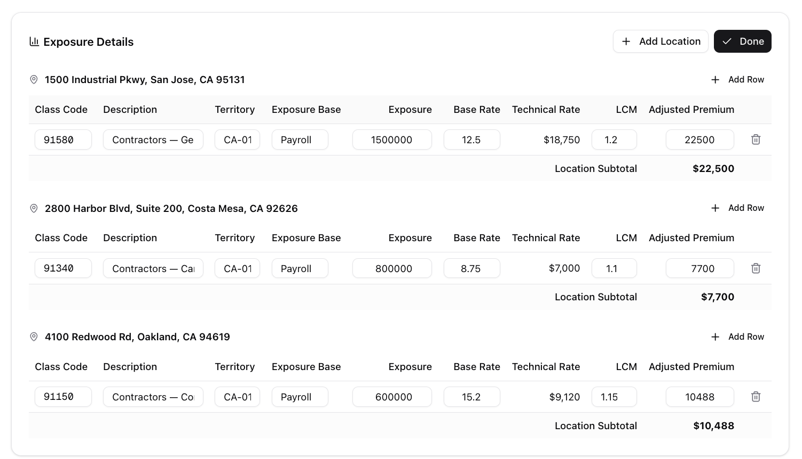

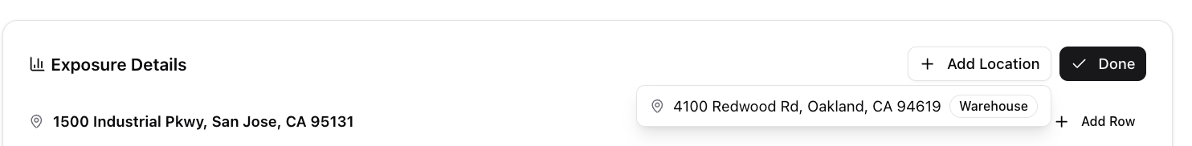

Priced Forms

The UW or the AI model can offer additional coverages such as Inland Marine or Excess. The Amount will be displayed for the additional coverage per the rate basis selected.

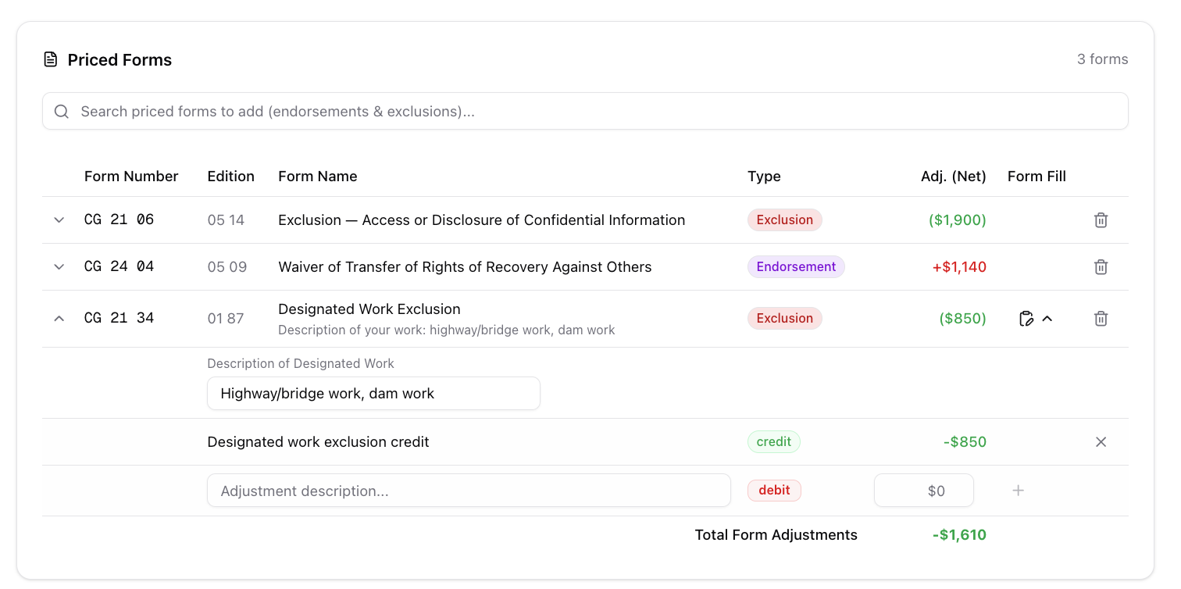

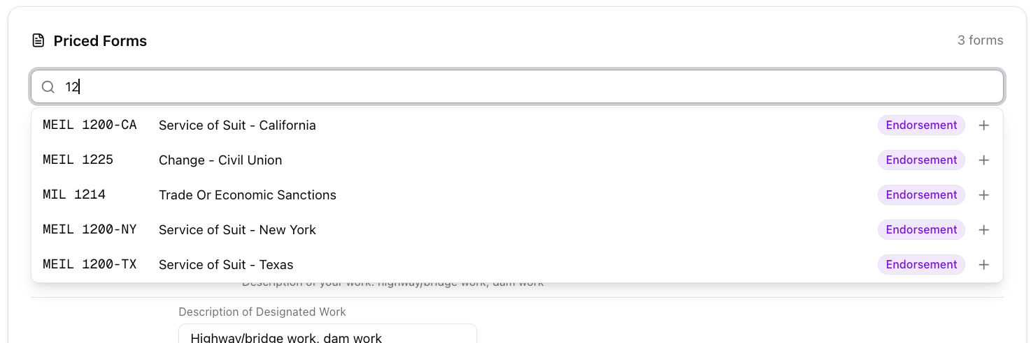

Loss Details

The UW or the AI model can offer additional coverages such as Inland Marine or Excess. The Amount will be displayed for the additional coverage per the rate basis selected.

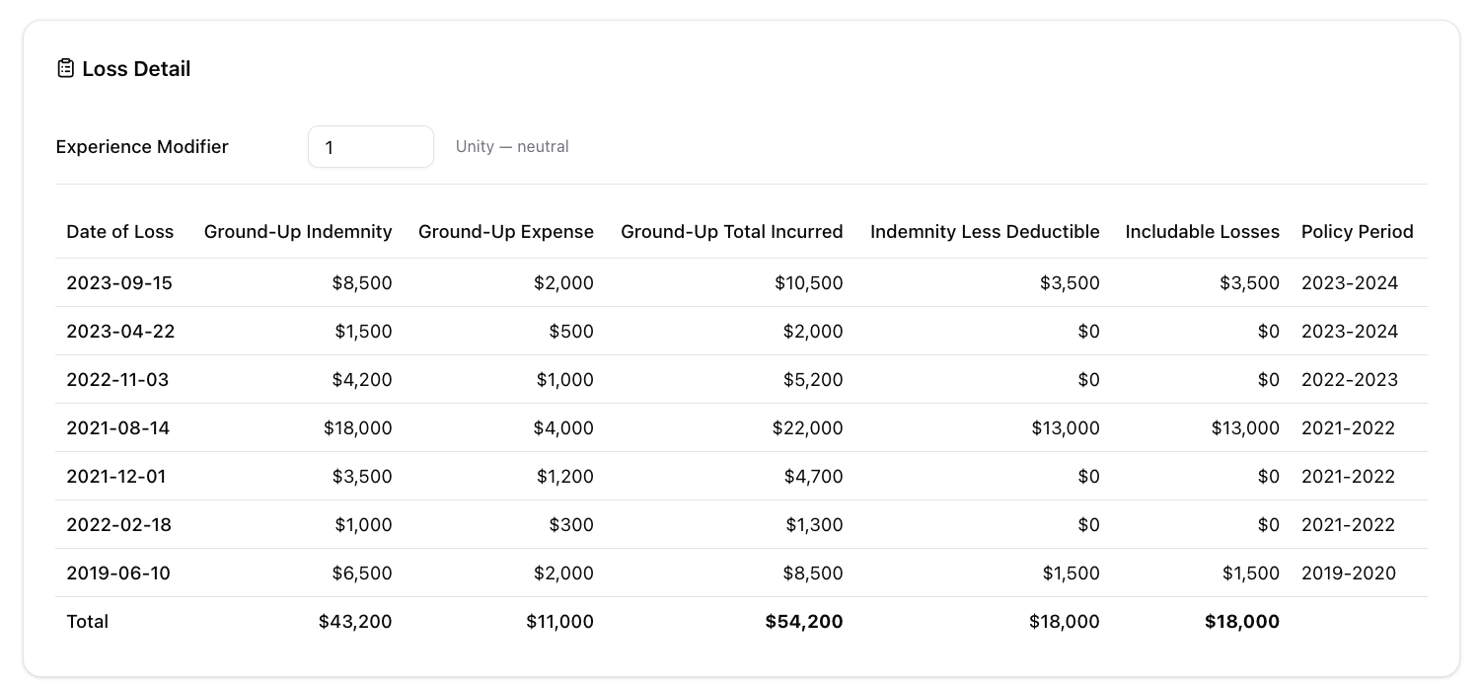

Forms Tab
A two-column layout (2/3 left worksheets, 1/3 right sticky price summary). This is the core pricing workspace.

Interaction points

TBD

Key inputs

The page card sections must be highly flexible and configurable. The following page cards will be constructed based on a JSON-based configuration document to allow flexibility for future products and changes.The following proposal cards will be driven by this configuration:

General Liability
- Additional Coverages

Deductibles

Fees

The tabs for Exposure Details and Price Forms will be based on a configuration tables and integrations with HX and FAST.

Key outputs

TBD

Acceptance criteria

TBD

Out of scope

TBD

Rating and pricing integration (EPIC-80, UW-SUPPORT)

Description

TBD

Interaction points

TBD

Key inputs

TBD

Key outputs

TBD

Acceptance criteria

TBD

Out of scope

TBD

TITLE (EPIC-90,UW-SUPPORT)

Description

TBD

Interaction points

TBD

Key inputs

TBD

Key outputs

TBD

Acceptance criteria

TBD

Out of scope

TBD

TITLE (EPIC-100, ,UW-SUPPORT)

Description

TBD

Interaction points

TBD

Key inputs

TBD

Key outputs

TBD

Acceptance criteria

TBD

Out of scope

TBD

TITLE (EPIC-110,ALL-STAGES)

Description

TBD

Interaction points

TBD

Key inputs

TBD

Key outputs

TBD

Acceptance criteria

TBD

Out of scope

TBD

TITLE (EPIC-120,ALL-STAGES

Description

TBD

Interaction points

TBD

Key inputs

TBD

Key outputs

TBD

Acceptance criteria

TBD

Out of scope

TBD

TITLE (EPIC-130,ALL-STAGES

Description

TBD

Interaction points

TBD

Key inputs

TBD

Key outputs

TBD

Acceptance criteria

TBD

Out of scope

TBD

TITLE (EPIC-140,ALL-STAGES)

Description

TBD

Interaction points

TBD

Key inputs

TBD

Key outputs

TBD

Acceptance criteria

TBD

Out of scope

TBD

TITLE (EPIC-150,ALL-STAGES

Description

TBD

Interaction points

TBD

Key inputs

TBD

Key outputs

TBD

Acceptance criteria

TBD

Out of scope

TBD

TITLE (EPIC-160,ALL-STAGES

Description

TBD

Interaction points

TBD

Key inputs

TBD

Key outputs

TBD

Acceptance criteria

TBD

Out of scope

TBD

